//insertion in an array at a particular position

#include<stdio.h>

#include<stdlib.h>

int main()

{

int x,p,n,i,a[100];

printf("Enter number of elements\n");

scanf("%d",&n);

for(i=0;i<n;i++)

{

printf("Enter element at position %d:\n",i+1);

scanf("%d",&a[i]);

}

printf("The elements are:\n");

for(i=0;i<n;i++)

printf("%d ",a[i]);

printf("\nEnter an element and its position in the array\n");

scanf("%d %d",&x,&p);

if(p>n+1 || p<0)

{

printf("Position is out of bounds\n");

exit(1);

}

else

{

for(i=n;i>=0 && i>=p;i--)

a[i]=a[i-1];

a[p-1]=x;

n=n+1;

printf("The elements now are:\n");

for(i=0;i<n;i++)

printf("%d ",a[i]);

}

}

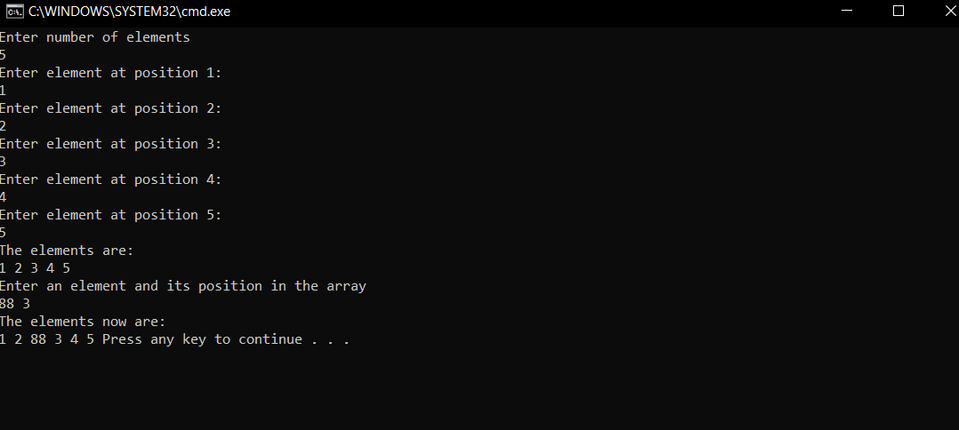

//Searching element in an array

#include<stdio.h>

#include<stdlib.h>

int main()

{

int x,n,i,a[100],p;

printf("Enter number of elements\n");

scanf("%d",&n);

for(i=0;i<n;i++)

{

printf("Enter element at position %d:\n",i+1);

scanf("%d",&a[i]);

}

printf("The elements are:\n");

for(i=0;i<n;i++)

printf("%d ",a[i]);

printf("\nEnter an element you want to search in the array\n");

scanf("%d",&x);

for(i=0;i<n;i++)

if(a[i]==x)

{

p=i+1;

break;

}

if(i>=n)

printf("Element not in the list\n");

else

printf("Element is at position %d\n",p);

}

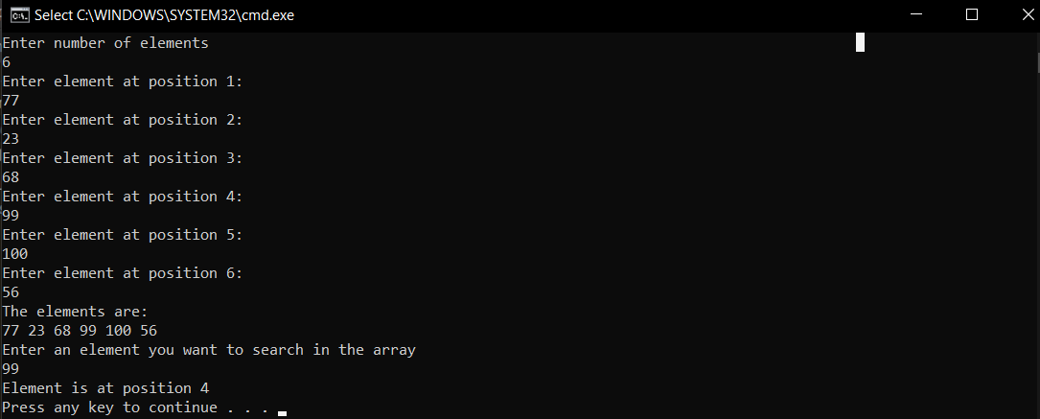

//Finding smallest and largest elements in an array

#include<stdio.h>

int main()

{

int n,i,a[100],large,small;

printf("Enter number of elements\n");

scanf("%d",&n);

for(i=0;i<n;i++)

{

printf("Enter element at position %d:\n",i+1);

scanf("%d",&a[i]);

}

printf("The elements are:\n");

for(i=0;i<n;i++)

printf("%d ",a[i]);

large=small=a[0];

for(i=1;i<n;i++)

{

if(large<a[i])

large=a[i];

if(small>a[i])

small=a[i];

}

printf("\nThe largest element is %d and the smallest element is %d\n",large,small);

}

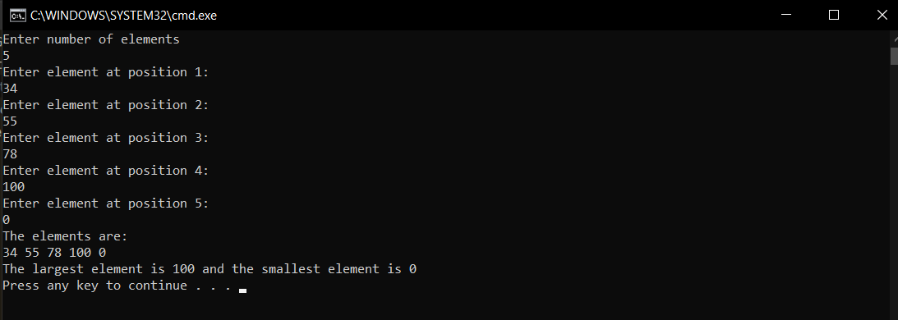

//Addition of matrices

#include<stdio.h>

int main()

{

int i,j,a[50][50],b[50][50],r,c,sum[50][50];

printf("Enter number of rows\n");

scanf("%d",&r);

printf("Enter number of columns\n");

scanf("%d",&c);

printf("Enter elements in the first matrix\n");

for(i=0;i<r;i++)

for(j=0;j<c;j++)

{

printf("Enter element at position %d %d\n",i+1,j+1);

scanf("%d",&a[i][j]);

}

printf("\nEnter elements in the second matrix");

for(i=0;i<r;i++)

for(j=0;j<c;j++)

{

printf("Enter element at position %d,%d\n",i+1,j+1);

scanf("%d",&b[i][j]);

}

printf("The two matrices are:\n");

for(i=0;i<r;i++)

{

for(j=0;j<c;j++)

printf("%d ",a[i][j]);

printf("\n");

}

printf("\n");

for(i=0;i<r;i++)

{

for(j=0;j<c;j++)

printf("%d ",b[i][j]);

printf("\n");

}

for(i=0;i<r;i++)

for(j=0;j<c;j++)

sum[i][j]=a[i][j]+b[i][j];

printf("\nThe sum of the two matrices is\n");

for(i=0;i<r;i++)

{

for(j=0;j<c;j++)

printf("%d ",sum[i][j]);

printf("\n");

}

printf("\n");

}

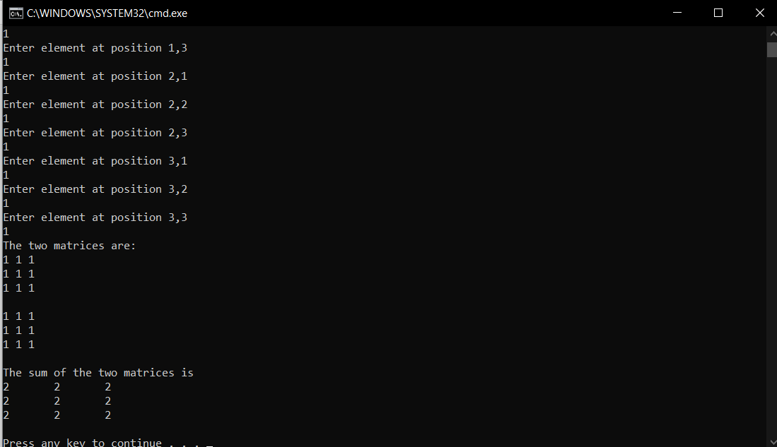

//Matrix multiplication

#include<stdio.h>

int main()

{

int i,j,a[50][50],b[50][50],r,c,c2,sum[50][50],k;

printf("Enter number of rows of first matrix\n");

scanf("%d",&r);

printf("Enter number of columns\n");

scanf("%d",&c);

printf("Enter number of columns in the second matrix\n");

scanf("%d",&c2);

printf("Enter elements in the first matrix\n");

for(i=0;i<r;i++)

for(j=0;j<c;j++)

{

printf("Enter element at position %d %d\n",i+1,j+1);

scanf("%d",&a[i][j]);

}

printf("\nEnter elements in the second matrix\n");

for(i=0;i<c;i++)

for(j=0;j<c2;j++)

{

printf("Enter element at position %d,%d\n",i+1,j+1);

scanf("%d",&b[i][j]);

}

printf("The two matrices are:\n");

for(i=0;i<r;i++)

{

for(j=0;j<c;j++)

printf("%d ",a[i][j]);

printf("\n");

}

printf("\n");

for(i=0;i<c;i++)

{

for(j=0;j<c2;j++)

printf("%d ",b[i][j]);

printf("\n");

}

for(i=0;i<r;i++)

for(j=0;j<c2;j++)

{

sum[i][j]=0;

for(k=0;k<c;k++)

sum[i][j]+=a[i][k]\*b[k][j];

}

printf("\n");

printf("The product of the matrices is\n");

for(i=0;i<r;i++)

{

for(j=0;j<c2;j++)

printf("%d ",sum[i][j]);

printf("\n");

}

}

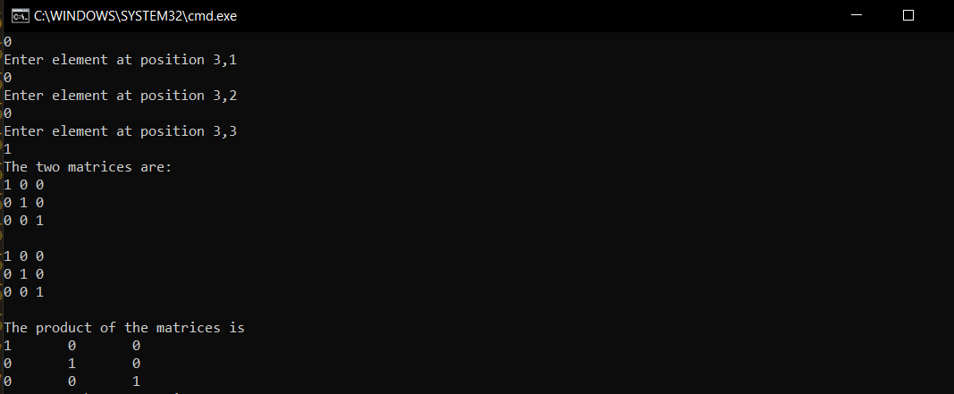

//Transpose of a matrix

#include<stdio.h>

int main()

{

int i,j,r,c;

printf("Enter number of rows\n");

scanf("%d",&r);

printf("Enter number of columns\n");

scanf("%d",&c);

int a[r][c];

printf("Enter elements in the matrix\n");

for(i=0;i<r;i++)

for(j=0;j<c;j++)

{

printf("Enter element at position %d %d\n",i+1,j+1);

scanf("%d",&a[i][j]);

}

printf("The original matrix is:\n");

for(i=0;i<r;i++)

{

for(j=0;j<c;j++)

printf("%d ",a[i][j]);

printf("\n");

}

printf("The transpose of the matrix is:\n");

for(j=0;j<c;j++)

{

for(i=0;i<r;i++)

printf("%d ",a[i][j]);

printf("\n");

}

}

